PROJECT REPORT





CLASS XII
2023 - 24

NAME :-

ROLL NO. :-

ST. GEORGE’S SCHOOL

ALAKNANDA, NEW DELHI

CERTIFICATE

This is to certify that …………………………… of
class XII, of St. George’s School, Alaknanda, New Delhi
has completed this project report under the guidance of
Mr. DEEPAK SHARMA during the academic year 2023-24.

Signature of the Teacher:

Signature of Head of the School: ________________________

School Seal:

ACKNOWLEDGEMENT

I express my heartfelt thanks to respected Director Dr. SARA GEORGE and the principal Ms. ANJALI MASSEY for having provided me with the opportunity to complete my project.
I extend my deep gratitude to my teacher Mr. DEEPAK SHARMA, who has guided me throughout the project with his valuable suggestions to enhance the quality of my project. Without his support this project would not have taken its present shape.

Signature of the Student:

INDEX
- INTRODUCTION
- HARDWARE & SOFTWARE REQUIREMENT
- CSV DATA FILE
- SOURCE CODE
- OUTPUT SCREEN
- BIBLIOGRAPHY

Hardware & Software Requirement

Hardware Requirement
PC/Laptop/MacBook with
Intel core/i3/i5/i7 or any equivalent
With at least 2 GB RAM
10 MB free space on Hard Disk
LCD/LED
Operating System & Compiler
MS Windows/Ubuntu/MacOS

Python IDLE 3.x
OR
colab.research.google.com (gmail account)

and/or
MS- EXCEL
OR
OPEN OFFICE CALC

CSV FILE

EMPLOYEE.CSV
EMPNO | NAME | GENDER | BASIC | DA | HRA | CCA | PF | TOTAL | NET
1 | JOHN | M | 5000 | 2500 | 1500 | 500 | 600 | 10100 | 9500
2 | MOHAN | M | 3000 | 1500 | 900 | 300 | 360 | 6060 | 5700
3 | SOHAN | M | 2000 | 1000 | 600 | 200 | 240 | 4040 | 3800
4 | RADHA | F | 5000 | 2500 | 1500 | 500 | 600 | 10100 | 9500
5 | GEETA | F | 6000 | 3000 | 1800 | 600 | 720 | 12120 | 11400
6 | SIMRAN | F | 2500 | 1250 | 750 | 250 | 300 | 5050 | 4750
7 | PRIYA | F | 3500 | 1750 | 1050 | 350 | 420 | 7070 | 6650
8 | SIMMI | F | 8000 | 4000 | 2400 | 800 | 960 | 16160 | 15200
9 | PREM | M | 5000 | 2500 | 1500 | 500 | 600 | 10100 | 9500
10 | ASHWIN | M | 6000 | 3000 | 1800 | 600 | 720 | 12120 | 11400

Source Code
import pandas as pd
import numpy as np
import matplotlib.pyplot as plt
from tabulate import tabulate
while True:
username=input("Enter User Name : ")
password=input("\nEnter Password : ")
if username == "deepak" and password== "sharma":
print("\nWelcome to EMPLOYEES MANAGEMENT SYSTEM\n")
break
else:
print("Invalid Username or Password")
while True:
print('\t\t *** Employees Data Analysis Project *** ')
print('\n\t\t\t1. Data Analysis')
print('\n\t\t\t2. Data Visualization')
print('\n\t\t\t3. Data Operations')
print('\n\t\t\t4. Exit\n')
choice=int(input('Select your Choice [1-4] : '))
if choice==1:
while True:
print('\t*** EMPLOYEES MANAGEMENT SYSTEM ***\n')
print('*'*50)
print("\n\t\t1. Show Employees Data")
print("\n\t\t2. Show Data Name-Wise")
print('\n\t\t3. Show first nth records')
print("\n\t\t4. Show last nth records")
print("\n\t\t5. Display employee with highest Salary")
print('\n\t\t6. Display employee with lowest Salary')
print("\n\t\t7. For Exit the program\n\n")
choice = int(input("Enter Your Choice [1-7] : "))
if choice == 1:
print("\nEmployees Data :\n\n")
df=pd.read_csv('D:\\Deepak\\2023-24\\XII IP\\Projects IP\\aastha_employees.csv')
print(tabulate(df,showindex=False,headers=['EMPNO','NAME','GENDER','BASIC','DA','HRA','CCA','PF','TOTAL','NET'],tablefmt='pretty'))
elif choice == 2:
print("\nEmployees Data Name - Wise :\n\n")
df=pd.read_csv('D:\\Deepak\\2023-24\\XII IP\\Projects IP\\aastha_employees.csv',usecols = ['NAME','GENDER','BASIC','DA','HRA','CCA','PF','TOTAL','NET'])
df = df.sort_values(by='NAME') print(tabulate(df,showindex=False,headers=['NAME','GENDER','BASIC','DA','HRA','CCA','PF','TOTAL','NET'],tablefmt='pretty'))
elif choice == 3:
print("\nFirst N Rows \n\n")
df=pd.read_csv('D:\\Deepak\\2023-24\\XII IP\\Projects IP\\aastha_employees.csv')
df = df.sort_values(by='EMPNO')
nth = int(input("How many rows to display? : "))
print(tabulate(df.head(nth),showindex=False,headers=['EMPNO','NAME','GENDER','BASIC','DA','HRA','CCA','PF','TOTAL','NET'],tablefmt='pretty'))
elif choice == 4:
print("\nLast N Rows \n\n")
df=pd.read_csv('D:\\Deepak\\2023-24\\XII IP\\Projects IP\\aastha_employees.csv')
df = df.sort_values(by='EMPNO')
nth = int(input("How many rows to display? : ")) print(tabulate(df.tail(nth),showindex=False,headers=['EMPNO','NAME','GENDER','BASIC','DA','HRA','CCA','PF','TOTAL','NET'],tablefmt='pretty'))
elif choice == 5:
print("\nDisplay employee with highest Salary :\n\n")
df=pd.read_csv('D:\\Deepak\\2023-24\\XII IP\\Projects IP\\aastha_employees.csv')
df = df.sort_values(by='NET') print(tabulate(df.tail(1),showindex=False,headers=['EMPNO','NAME','GENDER','BASIC','DA','HRA','CCA','PF','TOTAL','NET'],tablefmt='pretty'))
elif choice==6:
print("\nDisplay employee with highest Salary :\n\n")
df=pd.read_csv('D:\\Deepak\\2023-24\\XII IP\\Projects IP\\aastha_employees.csv')
df = df.sort_values(by='NET')
print(tabulate(df.head(1),showindex=False,headers=['EMPNO','NAME','GENDER','BASIC','DA','HRA','CCA','PF','TOTAL','NET'],tablefmt='pretty'))
elif choice==7:
print('Exit to main menu............')
break
else:
print('Invalid Choice, Retry 1/2/3/4/5/6/7')
elif choice==2:
while True:
print('Data Visualization')
print('\n\t1. Plot Line Chart (Name and Basic Salary)')
print('\n\t2. Plot Bar Chart Vertical(Name and Basic Salary)')
print('\n\t3. Plot Bar Horizontal Chart (Name and Basic Salary)')
print('\n\t4. Plot Histogram (Basic Salary)')
print('\n\t5. Exit\n')
choic=int(input('Select your Choice [1-4] : '))

if choic==1:
print('Line Chart')
df=pd.read_csv('D:\\Deepak\\2023-24\\XII IP\\Projects IP\\aastha_employees.csv')
df['NAME'] = ['JOHN','MOHAN','SOHAN','RADHA','GEETA','SIMRAN','PRIYA','SIMMI','PREM','ASHWIN']
NAME=df["NAME"]
BASIC=df["BASIC"]
plt.ylabel("Basic Salary ----------->")
plt.xlabel("Name -------->")
plt.title("*** Name and Basic Salary ***")
plt.plot(NAME,BASIC, color='r')
plt.grid()
plt.savefig('emp_line.pdf')
plt.show()
elif choic==2:
print('Bar Chart')
df=pd.read_csv('D:\\Deepak\\2023-24\\XII IP\\Projects IP\\aastha_employees.csv')
df['NAME'] = ['JOHN','MOHAN','SOHAN','RADHA','GEETA','SIMRAN','PRIYA','SIMMI','PREM','ASHWIN']
NAME=df["NAME"]
BASIC=df["BASIC"]
plt.ylabel("BASIC")
plt.title("*** Name and Basic Salary ***")
plt.bar(NAME,BASIC, color='r')
plt.grid()
plt.savefig('emp_bar.pdf')
plt.show()
elif choic==3:
print('Bar Chart')
df=pd.read_csv('D:\\Deepak\\2023-24\\XII IP\\Projects IP\\aastha_employees.csv')
df['NAME'] = ['JOHN','MOHAN','SOHAN','RADHA','GEETA','SIMRAN','PRIYA','SIMMI','PREM','ASHWIN']
NAME=df["NAME"]
BASIC=df["BASIC"]
plt.xlabel("Basic Salary")
plt.title("Name and Basic Salary")
plt.barh(NAME,BASIC, color='r')
plt.grid()
plt.savefig('emp_barh.pdf')
plt.show()
elif choic==4:
print('Histogram')
df=pd.read_csv('D:\\Deepak\\2023-24\\XII IP\\Projects IP\\aastha_employees.csv')
df['NAME'] = ['JOHN', 'MOHAN','SOHAN','RADHA','GEETA', 'SIMRAN','PRIYA','SIMMI','PREM','ASHWIN']
NAME=df["NAME"]
BASIC=df["BASIC"]
plt.title("Name and Basic Salary")
plt.hist(BASIC, color='r')
plt.grid()
plt.savefig('emp_hist.pdf')
plt.show()

elif choic==5:
print('Exit to main menu........')
break
else:
print('Invalid choice')
elif choice==3:
while True:
print('Data Operations')
print('\n\t1. Add a row to Dataframe')
print('\n\t2. Remove a row to Dataframe')
print('\n\t3. Add a Column to Dataframe')
print('\n\t4. Remove a Column to Dataframe')
print('\n\t5. Exit\n')
choic=int(input('Select your Choice [1-5] : '))
if choic==1:
df=pd.read_csv('D:\\Deepak\\2023-24\\XII IP\\Projects IP\\aastha_employees.csv')
EMPNO = int(input('Employee No : '))
NAME= input('Employee Name : ')
GENDER = input('Gender [M/F/T] : ')
BASIC= int(input('Basic Salary : '))
DA=.50*BASIC
HRA=.30*BASIC
CCA=.10*BASIC
PF=.12*BASIC
TOTAL=BASIC + DA + CCA + PF
NET = TOTAL - PF
cr=df['EMPNO'].count() df1=pd.DataFrame({"EMPNO":EMPNO,"NAME":NAME,"GENDER":GENDER, "BASIC":BASIC,"DA":DA,"HRA":HRA, "CCA":CCA,"PF":PF,"TOTAL":TOTAL, "NET":NET}, index=[cr])
df=df.append(df1) print(tabulate(df,showindex=False,headers=['EMPNO','NAME','GENDER','BASIC','DA','HRA','CCA','PF','TOTAL','NET'],tablefmt='pretty'))
print('Record added Successfully..............')

elif choic==2:
df=pd.read_csv('D:\\Deepak\\2023-24\\XII IP\\Projects IP\\aastha_employees.csv')
print(tabulate(df,showindex=False,headers=['EMPNO','NAME','GENDER','BASIC','DA','HRA','CCA','PF','TOTAL','NET'],tablefmt='pretty'))
r=int(input("Enter the Employee Number to be removed : "))
df= df.drop(r-1) print(tabulate(df,showindex=False,headers=['EMPNO','NAME','GENDER','BASIC','DA','HRA','CCA','PF','TOTAL','NET'],tablefmt='pretty'))
print('Record deleted Successfully..............')
elif choic==3:
print('Add a Column')
df=pd.read_csv('D:\\Deepak\\2023-24\\XII IP\\Projects IP\\aastha_employees.csv')
print("Add Column DEPARTMENT : ") df['DEPARTMENT']=['HR','SALES','FINANCE','HR','SALES','FINANCE','HR','SALES','FINANCE','SALES'] print(tabulate(df,headers=['EMPNO','NAME','GENDER','BASIC','DA','HRA','CCA','PF','TOTAL','NET','DEPARTMENT'],tablefmt='pretty'))
print('Column added Successfully..............')
elif choic==4:
print('Remove a Column')
df=pd.read_csv('D:\\Deepak\\2023-24\\XII IP\\Projects IP\\aastha_employees.csv')
C=input("Enter the Column Name to remove : ")
C=C.upper()
df=df.drop(C,axis=1)
print(tabulate(df,tablefmt='pretty'))
print('Column removed Successfully..............')
elif choic==5:
print('Exit to main menu........')
break
else:
print('Invalid choice')
elif choice==4:
print('Exit from menu........')
break
else:
print('Invalid choice')

OUTPUT
SCREENS

Enter User Name : deepak
Enter Password : sharma
Welcome to EMPLOYEES MANAGEMENT SYSTEM
*** Employees Data Analysis Project ***
1. Data Analysis
2. Data Visualization
3. Data Operations
4. Exit
Select your Choice [1-4] : 1
*** EMPLOYEES MANAGEMENT SYSTEM ***
**************************************************
1. Show Employees Data
2. Show Data Name-Wise
3. Show first nth records
4. Show last nth records
5. Display employee with highest Salary
6. Display employee with lowest Salary
7. For Exit the program
Enter Your Choice [1-7] : 1
Employees Data :
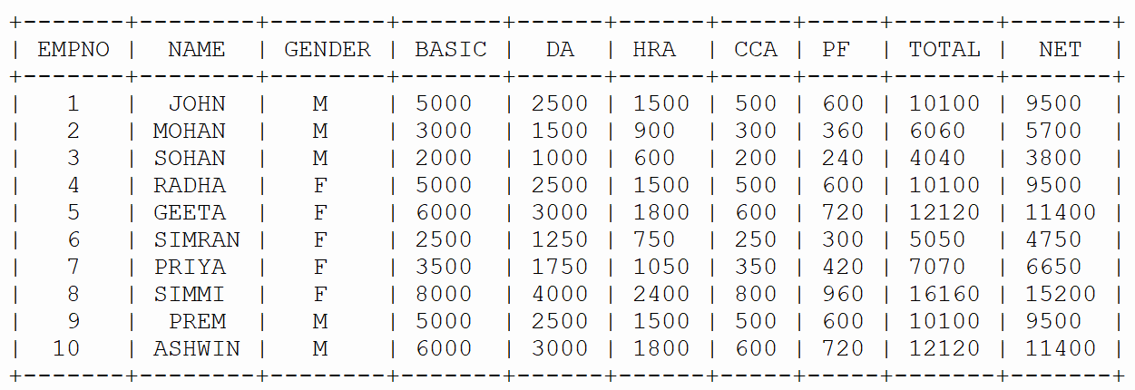
*** EMPLOYEES MANAGEMENT SYSTEM ***
**************************************************
1. Show Employees Data
2. Show Data Name-Wise
3. Show first nth records
4. Show last nth records
5. Display employee with highest Salary
6. Display employee with lowest Salary
7. For Exit the program
Enter Your Choice [1-8] : 2
Employees Data Name - Wise :
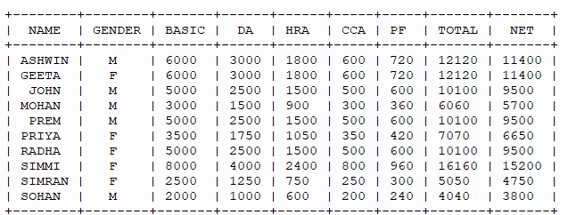

*** EMPLOYEES MANAGEMENT SYSTEM ***
**************************************************
1. Show Employees Data
2. Show Data Name-Wise
3. Show first nth records
4. Show last nth records
5. Display employee with highest Salary
6. Display employee with lowest Salary
7. For Exit the program
Enter Your Choice [1-8] : 3
First N Rows
How many rows to display? : 4
+-------+-------+--------+-------+------+------+-----+-----+-------+------+
| EMPNO | NAME | GENDER | BASIC | DA | HRA | CCA | PF | TOTAL | NET |
+-------+-------+--------+-------+------+------+-----+-----+-------+------+
| 1 | JOHN | M | 5000 | 2500 | 1500 | 500 | 600 | 10100 | 9500 |
| 2 | MOHAN | M | 3000 | 1500 | 900 | 300 | 360 | 6060 | 5700 |
| 3 | SOHAN | M | 2000 | 1000 | 600 | 200 | 240 | 4040 | 3800 |
| 4 | RADHA | F | 5000 | 2500 | 1500 | 500 | 600 | 10100 | 9500 |
+-------+-------+--------+-------+------+------+-----+-----+-------+------+

*** EMPLOYEES MANAGEMENT SYSTEM ***
**************************************************
1. Show Employees Data
2. Show Data Name-Wise
3. Show first nth records
4. Show last nth records
5. Display employee with highest Salary
6. Display employee with lowest Salary
7. For Exit the program
Enter Your Choice [1-8] : 4
Last N Rows
How many rows to display? : 3
+-------+--------+--------+-------+------+------+-----+-----+-------+-------+
| EMPNO | NAME | GENDER | BASIC | DA | HRA | CCA | PF | TOTAL | NET |
+-------+--------+--------+-------+------+------+-----+-----+-------+-------+
| 8 | SIMMI | F | 8000 | 4000 | 2400 | 800 | 960 | 16160 | 15200 |
| 9 | PREM | M | 5000 | 2500 | 1500 | 500 | 600 | 10100 | 9500 |
| 10 | ASHWIN | M | 6000 | 3000 | 1800 | 600 | 720 | 12120 | 11400 |
+-------+--------+--------+-------+------+------+-----+-----+-------+-------+

*** EMPLOYEES MANAGEMENT SYSTEM ***
**************************************************
1. Show Employees Data
2. Show Data Name-Wise
3. Show first nth records
4. Show last nth records
5. Display employee with highest Salary
6. Display employee with lowest Salary
7. For Exit the program
Enter Your Choice [1-8] : 5
Display employee with highest Salary :
+-------+-------+--------+-------+------+------+-----+-----+-------+-------+
| EMPNO | NAME | GENDER | BASIC | DA | HRA | CCA | PF | TOTAL | NET |
+-------+-------+--------+-------+------+------+-----+-----+-------+-------+
| 8 | SIMMI | F | 8000 | 4000 | 2400 | 800 | 960 | 16160 | 15200 |
+-------+-------+--------+-------+------+------+-----+-----+-------+-------+
*** EMPLOYEES MANAGEMENT SYSTEM ***
**************************************************
1. Show Employees Data
2. Show Data Name-Wise
3. Show first nth records
4. Show last nth records
5. Display employee with highest Salary
6. Display employee with lowest Salary
7. For Exit the program
Enter Your Choice [1-8] : 6
Display employee with lowest Salary :
+-------+-------+--------+-------+------+-----+-----+-----+-------+------+
| EMPNO | NAME | GENDER | BASIC | DA | HRA | CCA | PF | TOTAL | NET |
+-------+-------+--------+-------+------+-----+-----+-----+-------+------+
| 3 | SOHAN | M | 2000 | 1000 | 600 | 200 | 240 | 4040 | 3800 |
+-------+-------+--------+-------+------+-----+-----+-----+-------+------+

*** EMPLOYEES MANAGEMENT SYSTEM ***
**************************************************
1. Show Employees Data
2. Show Data Name-Wise
3. Show first nth records
4. Show last nth records
5. Display employee with highest Salary
6. Display employee with lowest Salary
7. For Exit the program
Enter Your Choice [1-8] : 7
Exit to Main Menu……….
*** Employees Data Analysis Project ***
1. Data Analysis
2. Data Visualization
3. Data Operations
4. Exit
Select your Choice [1-4] : 2

Data Visualization
1. Plot Line Chart (Name and Basic Salary)
2. Plot Bar Chart Vertical (Name and Basic Salary)
3. Plot Bar Horizontal Chart (Name and Basic Salary)
4. Plot Histogram (Basic Salary)
5. Exit
Select your Choice [1-4] : 1
Line Chart
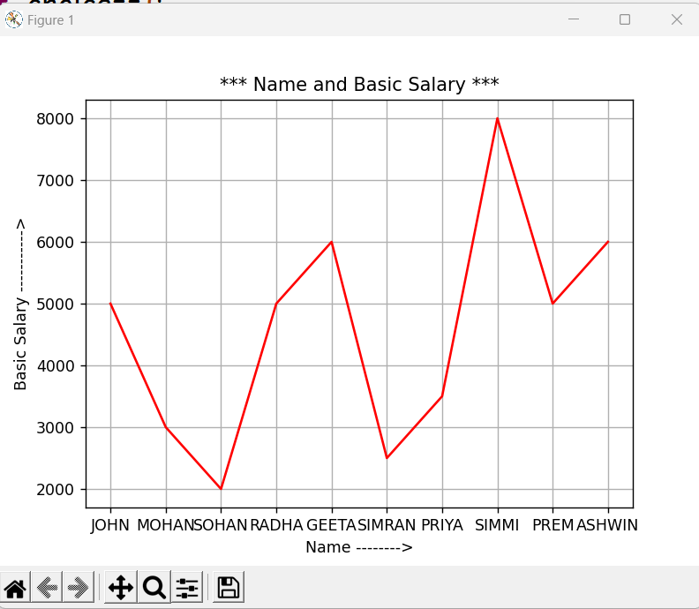

Data Visualization
1. Plot Line Chart (Name and Basic Salary)
2. Plot Bar Chart Vertical(Name and Basic Salary)
3. Plot Bar Horizontal Chart (Name and Basic Salary)
4. Plot Histogram (Basic Salary)
5. Exit
Select your Choice [1-4] : 2
Bar Chart

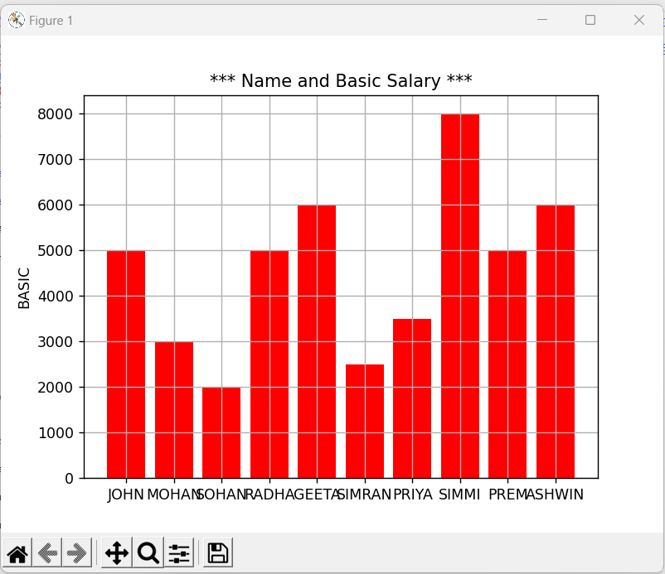

Data Visualization
1. Plot Line Chart (Name and Basic Salary)
2. Plot Bar Chart Vertical(Name and Basic Salary)
3. Plot Bar Horizontal Chart (Name and Basic Salary)
4. Plot Histogram (Basic Salary)
5. Exit
Select your Choice [1-4] : 3
Bar Chart

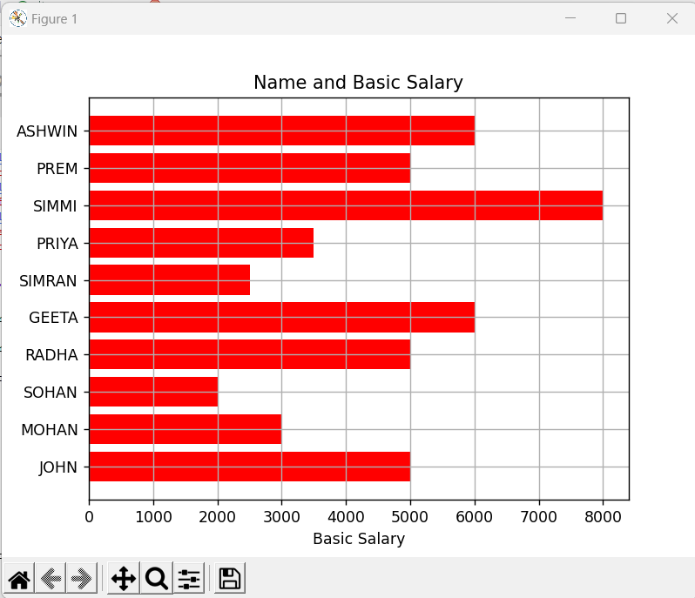

Data Visualization
1. Plot Line Chart (Name and Basic Salary)
2. Plot Bar Chart Vertical (Name and Basic Salary)
3. Plot Bar Horizontal Chart (Name and Basic Salary)
4. Plot Histogram (Basic Salary)
5. Exit
Select your Choice [1-4]: 4
Histogram
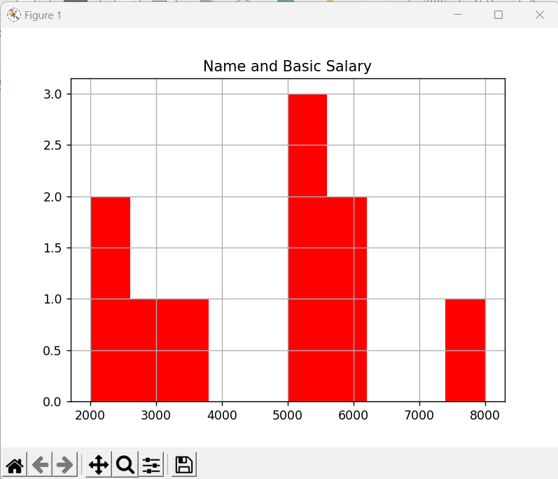

Welcome to EMPLOYEES MANAGEMENT SYSTEM
*** Employees Data Analysis Project ***
1. Data Analysis
2. Data Visualization
3. Data Operations
4. Exit
Select your Choice [1-4] : 3
Data Operations
1. Add a row to Dataframe
2. Remove a row to Dataframe
3. Add a Column to Dataframe
4. Remove a Column to Dataframe
5. Exit
Select your Choice [1-5] : 1
Employee No : 101
Employee Name : Rajesh
Gender [M/F/T] : M
Basic Salary : 60000
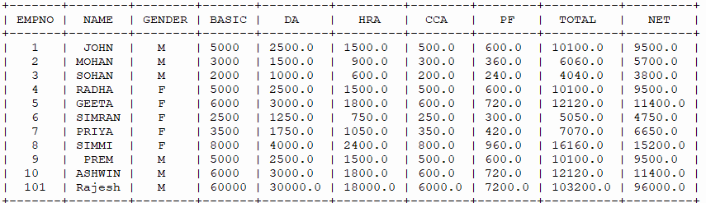
Record added Successfully..............

Data Operations
1. Add a row to Dataframe
2. Remove a row to Dataframe
3. Add a Column to Dataframe
4. Remove a Column to Dataframe
5. Exit
Select your Choice [1-5] : 2
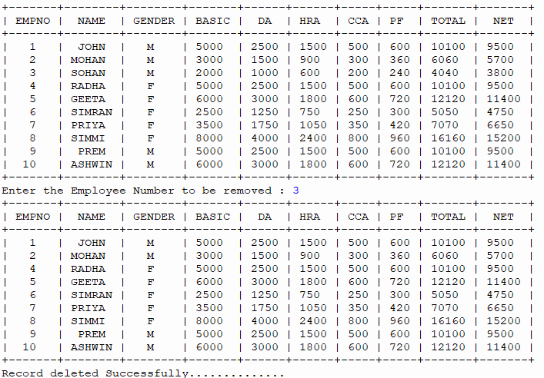
Add a Column
Add Column DEPARTMENT :
+---+-------+--------+--------+-------+------+------+-----+-----+-------+-------+------------+
EMPNO NAME GENDER BASIC DA HRA | CCA | PF | TOTAL | NET | DEPARTMENT |
+---+-------+--------+--------+-------+------+------+-----+-----+-------+-------+------------+
| 0 | 1 | JOHN | M | 5000 | 2500 | 1500 | 500 | 600 | 10100 | 9500 | HR |
| 1 | 2 | MOHAN | M | 3000 | 1500 | 900 | 300 | 360 | 6060 | 5700 | SALES |
| 2 | 3 | SOHAN | M | 2000 | 1000 | 600 | 200 | 240 | 4040 | 3800 | FINANCE |
| 3 | 4 | RADHA | F | 5000 | 2500 | 1500 | 500 | 600 | 10100 | 9500 | HR |
| 4 | 5 | GEETA | F | 6000 | 3000 | 1800 | 600 | 720 | 12120 | 11400 | SALES |
| 5 | 6 | SIMRAN | F | 2500 | 1250 | 750 | 250 | 300 | 5050 | 4750 | FINANCE |
| 6 | 7 | PRIYA | F | 3500 | 1750 | 1050 | 350 | 420 | 7070 | 6650 | HR |
| 7 | 8 | SIMMI | F | 8000 | 4000 | 2400 | 800 | 960 | 16160 | 15200 | SALES |
| 8 | 9 | PREM | M | 5000 | 2500 | 1500 | 500 | 600 | 10100 | 9500 | FINANCE |
| 9 | 10 | ASHWIN | M | 6000 | 3000 | 1800 | 600 | 720 | 12120 | 11400 | SALES |
+---+-------+--------+--------+-------+------+------+-----+-----+-------+-------+------------+
Column added Successfully..............
Data Operations
1. Add a row to Dataframe
2. Remove a row to Dataframe
3. Add a Column to Dataframe
4. Remove a Column to Dataframe
5. Exit
Select your Choice [1-5] : 4
Remove a Column
Enter the Column Name to remove : GENDER
+---+----+--------+------+------+------+-----+-----+-------+-------+
| 0 | 1 | JOHN | 5000 | 2500 | 1500 | 500 | 600 | 10100 | 9500 |
| 1 | 2 | MOHAN | 3000 | 1500 | 900 | 300 | 360 | 6060 | 5700 |
| 2 | 3 | SOHAN | 2000 | 1000 | 600 | 200 | 240 | 4040 | 3800 |
| 3 | 4 | RADHA | 5000 | 2500 | 1500 | 500 | 600 | 10100 | 9500 |
| 4 | 5 | GEETA | 6000 | 3000 | 1800 | 600 | 720 | 12120 | 11400 |
| 5 | 6 | SIMRAN | 2500 | 1250 | 750 | 250 | 300 | 5050 | 4750 |
| 6 | 7 | PRIYA | 3500 | 1750 | 1050 | 350 | 420 | 7070 | 6650 |
| 7 | 8 | SIMMI | 8000 | 4000 | 2400 | 800 | 960 | 16160 | 15200 |
| 8 | 9 | PREM | 5000 | 2500 | 1500 | 500 | 600 | 10100 | 9500 |
| 9 | 10 | ASHWIN | 6000 | 3000 | 1800 | 600 | 720 | 12120 | 11400 |
+---+----+--------+------+------+------+-----+-----+-------+-------+
Column removed Successfully..............
Data Operations
1. Add a row to Dataframe
2. Remove a row to Dataframe
3. Add a Column to Dataframe
4. Remove a Column to Dataframe
5. Exit
Select your Choice [1-5] : 5
Exit to main menu........
*** Employees Data Analysis Project ***
1. Data Analysis
2. Data Visualization
3. Data Operations
4. Exit
Select your Choice [1-4] : 4
Exit from menu........

BIBLIOGRAPHY

We took the information for our project report from the following sources:
Reference books:
1. Informatics Practices by Sumita Arora.
2. Complete reference with Python
3. Data Analysis-Python
4. NCERT Text Book
Websites:
- https://www.python.org.in
- https://www.google.com
- https://www.cbseacademic.nic.in
- https://www.Kaggle.com

